Chapter 5 HW

5.13

a.



b.



c.



d. Contents of general-purpose register can never be negative or zero at the same time, so this situation is impossible.

e.



5.14

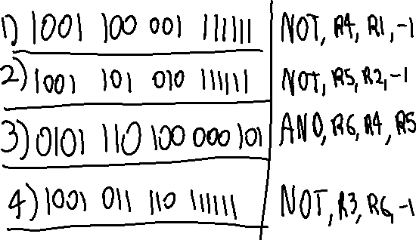

5.15

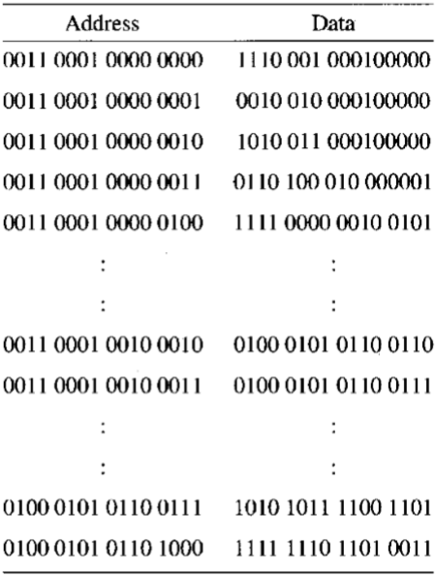



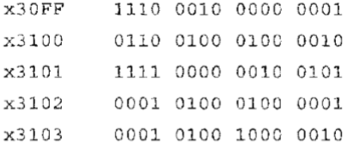5.23

